Currie Primary School

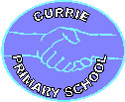

Health and Wellbeing Policy

Every child has the right to the best possible health. Governments must provide good quality health care, clean water, nutritious food, and a clean environment and education on health and well-being so that children can stay healthy. Richer countries must help poorer countries achieve this.
Article 24 UN Convention on the Rights of the Child

Every child has the right to an education. Primary education must be free and different forms of secondary education must be available to every child. Discipline in schools must respect children’s dignity and their rights. Richer countries must help poorer countries achieve this.
Article 28 UN Convention on the Rights of the Child

Education must develop every child’s personality, talents and abilities to the full. It must encourage the child’s respect for human rights, as well as respect for their parents, their own and other cultures, and the environment.
Article 29 UN Convention on the Rights of the Child

June 2022

Currie Primary School

Health and Wellbeing Policy

Contents Page

Mission Statement 3

Rationale and Aims 4

Roles and responsibilities 6

Health and wellbeing organisers 7
Assessment, Recording and Reporting 8 Partnership working 9
Legal requirements 10
Appendix 1 – GIRFEC 11
Appendix 2 – HWB Bundles 13

MISSION STATEMENT
The approach to health and wellbeing at Currie Primary School follows Curriculum for Excellence (CfE) guidelines.
Curriculum for Excellence states that:
“Good health and wellbeing is central to effective learning and preparation for successful, independent living. This aspiration for every child and young person can only be met through a concerted approach: schools and their partners working together closely to plan their programmes for health and wellbeing explicitly, taking account of local circumstances and individual needs.”
(Health and Wellbeing: Principles and Practice, page 1)

“Everyone within each learning community, whatever their contact with children and young people may be, shares the responsibility for creating a positive ethos and climate of respect and trust – one in which everyone can make a positive contribution to the wellbeing of each individual within the school and the wider community.”
(Health and Wellbeing: Principles and Practice, page 3)

At Currie Primary, we value every individual. We seek to provide effective teaching and learning for all pupils. We strive to provide a welcoming, safe and secure environment, where staff and the wider community work together to encourage pupils to lead healthy lifestyles and to take responsibility for their own health and wellbeing.

We value the positive impact that good health has upon learning and the life of the school. We recognise and are committed to meeting the physical, mental, emotional and social health needs of all school community members. We value the expertise of other agencies and seek to promote health and wellbeing for all, through effective partnerships. We are committed to the best possible delivery of Curriculum for Excellence Health and Wellbeing experiences and outcomes.

As we are working towards Rights Respecting School accreditation, we at Currie Primary embed the United Nations Convention on the Rights of the Child (UNCRC) into our practice to ensure that children’s rights are actively promoted and respected within the school community. Many articles in the UNCRC are directly linked to children’s health and wellbeing.

RATIONALE AND AIMS

A health promoting school is a school that promotes, values and is committed to healthy lifestyles for all. At Currie Primary, we promote health and wellbeing throughout the whole school community, following Curriculum for Excellence guidelines.

Curriculum for Excellence looks at health and wellbeing in the context of the Challenges of the 21st century. At Currie Primary, we aim to develop in our pupils, the knowledge and understanding, skills, capabilities and attributes necessary for mental, emotional, social and physical wellbeing now and in the future. We aim to enable our pupils to:
- make informed decisions in order to improve their mental, emotional, social and physical wellbeing
- experience challenge and enjoyment
- experience positive aspects of healthy living and activity for themselves
- apply their mental, emotional, social and physical skills to pursue a healthy lifestyle
- make a successful move to the next stage of education or work
- establish a pattern of health and wellbeing which will be sustained into adult life, and which will help to promote the health and wellbeing of the next generation of Scottish children.
It also enables some to perform at high levels in sport or prepare for careers within the health and leisure industries,
(Health and Wellbeing: Principles and Practice, page 1)

At Currie Primary, we aim to support all our children to become successful learners, confident individuals, responsible citizens and effective contributors. We recognise that promoting health and wellbeing is the responsibility of all. We work together to create a positive ethos and a climate of mutual respect and trust. We aim to ensure that the GIRFEC (Getting It Right For Every Child) wellbeing indicators are at the centre of our practice and as a result all staff and partner agencies work within the SHANARRI wheel (see appendix 1). Our children will:
- have a nurturing environment
- be active
- feel respected
- be responsible
- feel included
- be safe
- feel safe
- be healthy
- experience achievement.

Our pupils are encouraged to develop a responsibility for their learning through:
- Sharing of learning intentions and success criteria to ensure that pupils are aware of what is expected of them
- Provision of appropriate feedback through self, peer and teacher assessment
- Promotion of reflection on where they are in their learning, and the next steps necessary for progression.

The framework for health and wellbeing provides a set of statements that describe the kinds of activities and opportunities our pupils will experience throughout school and our staff refer to these statements and to the more detailed experiences and outcomes when planning for teaching and learning (Appendix 2).

ROLES AND RESPONSIBILITIES
Staff
- Provide a supportive and caring environment
- Ensure the provision of lessons to cover all aspects of physical and mental wellbeing
- Liaise with, and involve individuals and agencies who can offer relevant expertise
- Liaise with parents and carers regarding programmes and developments
- Help pupils to learn how to take responsibility for themselves and the choices they make

Parents and pupils
- Ensure learners arrive at school on time having had the opportunity of a good night’s sleep, breakfast and provision made for a healthy balanced lunch
- Ensure learners are suitably dressed in school uniform with warm jacket or coat when appropriate
- Ensure learners have everything they need including homework, reading books, pencil case, PE kit, violins etc. to enable them to participate fully in all aspects of school life on offer

At Currie Primary School we can offer help for parents struggling to meet any of these responsibilities, for example we provide pencils, pens, rulers, PE kit etc. for children if required. We can also offer financial help to buy uniform (school polo shirts and sweatshirts), for trips and outings, provide access to our Breakfast Club, support access to free school meals and so on to ensure equity for all pupils in school. We monitor absences and lateness of pupils and work with parents of children at risk of missing out due to constant lateness / absence.

HEALTH AND WELLBEING ORGANISERS
Currie Primary is committed to the Curriculum for Excellence Health and Wellbeing Principles and Practice and aims to provide the opportunity for our pupils to be successful learners, confident individuals, responsible citizens and effective contributors in the following areas:
- Mental, emotional, social and physical wellbeing
  - Mental and emotional wellbeing
  - Social wellbeing
  - Physical wellbeing
- Planning for choices and change
- Physical education, physical activity and sport
  - Movement skills, competencies and concepts
  - Cooperation and competition
  - Evaluating and appreciating
- Food and health
  - Nutrition
  - Safe and hygienic practices
  - Food and the consumer
- Substance misuse
- Relationships, sexual health and parenthood

At Currie Primary, we are committed to maintaining and enhancing high standards in the teaching and learning of health and wellbeing. Our pupils are helped to understand the close links between the various aspects of health and wellbeing. All staff understand the role that health and wellbeing plays in the development of resilience, confidence, independent thinking, positive attitudes and a positive disposition, and are aware of their responsibilities in contributing towards these outcomes.

Partnership working between teachers, parents, pupils, health professionals, educational psychologists and sports specialists contributes to, and enhances, the health and wellbeing programme.

In planning, staff are familiar with and consider each area of health and wellbeing across the curriculum, taking account of individual needs and abilities. Pupils have the opportunity to work both individually and collaboratively. Teaching and learning experiences include active learning, outdoor learning, whole class teaching, role-play activities, multi-sensory approaches, individual work and small group discussions. Health and wellbeing experiences and outcomes are included in both discrete and interdisciplinary lessons. (Appendix 2 contains details of how our bundles ensure coverage of the Es and Os from CfE as well as progression in learning from Nursery to P7 within Health and wellbeing). Some experiences and outcomes are organised into the bundle ‘Ethos and life of the school’. These are covered discretely across all areas of our school and specifically in assembly using the Building Resilience Assembly resource.
ASSESSMENT, RECORDING AND REPORTING
The principles and practice of Assessment is for Learning are fully embedded at Currie Primary. We recognise the importance of assessment in providing a clear picture of the progress of each child, and in planning for future learning to ensure progression. Each child is given regular feedback to identify next steps and set personal targets.

Assessment in health and wellbeing takes account of the breadth and purpose of the wide range of experiences and outcomes in this area. Evidence of pupil progress may be gathered from health and wellbeing lessons as well as from observations of the child in general aspects of their school life, both inside and outside the classroom.

Assessment may take the form of specific assessment tasks, but progress may also be monitored by observations of how pupils are developing and applying their knowledge and understanding of skills within the wider life of the school. Assessment will also be linked to other areas of the curriculum, within and out with the classroom, where pupils apply their knowledge and skills in more complex, demanding or unfamiliar learning or social contexts.

Reporting to Parents, Teachers and Pupils
Parents – Learning Journals and consultation times are provided as well as an end of session summative report

Teachers – Pupil Profiles are passed on to the receiving teacher, as is a summary of work undertaken during the session.

Pupils – verbal and written comments feature in daily classroom practice, Learning Journals.

PARTNERSHIP WORKING
It is widely recognised that parents / carers, specialists and experts from other agencies can provide information, expertise and insights that our school staff would not normally be able to provide and as such we use and value the input of our parents / carers, specialist partners and agencies to complement and enhance the work of our classes. We work hard to foster strong and effective partnership working. We aim to foster collective responsibility for health and wellbeing that reflects the views of pupils, staff, parents, the wider community and key outside agencies.

We enjoy a positive working relationship with the following agencies in the promotion of health and wellbeing:
- Parents / carers
- PE Specialist
- Active Schools Coordinator
- Local and city wide sporting organisations such as EPSSA
- Additional Support for Learning (ASL) Service
- Literacy and Dyslexia Service
- Staff from Redhall and Woodlands Special Schools
- Educational Psychologist
- CAMHS
- Community nurse
- Occupational Therapy
- Therapy Inclusion Project
- Health Visitor
- Speech and Language Therapy
- Dietician
- Diabetic nurse
- Paediatrician
- Barnardos
- Downs Syndrome Scotland
- Social Services

LEGAL REQUIREMENTS
- Health-related activities within the school often involve the invitation of members of the community to take part in the educational process. Visits out with school may also take place. Health and Safety procedures, the appropriate use of Police checks (Protection of Vulnerable Groups) and risk assessments are used at all times. Parents/carers are fully informed of the details of such activities in advance.
- Staff within the school are required to promote equality of opportunity for all pupils.
- Staff within the school are required to follow Child Protection procedures (see Child Protection Policy)
- Staff receive regular update training in issues such as Child Protection, Asthma, Diabetes, First Aid etc.
- All pupils receive 2 hours of PE each week

Policy review date August 2025
Appendices
Appendix 1 - GIRFEC
Getting It Right For Every Child (GIRFEC) is the Scottish Government’s drive to improve outcomes for all children. The aim is that all children in Scotland are given every opportunity to develop to their full potential to become confident, responsible, and productive members of society.
Curriculum for Excellence refers to this as the Four Capacities which aim to enable every child to become a:
- successful learner
- confident individual
- responsible citizen
- effective contributor
In order to meet these goals, an agreed definition of wellbeing has been created. It is summarised in the Wellbeing Wheel.

SHANARRI
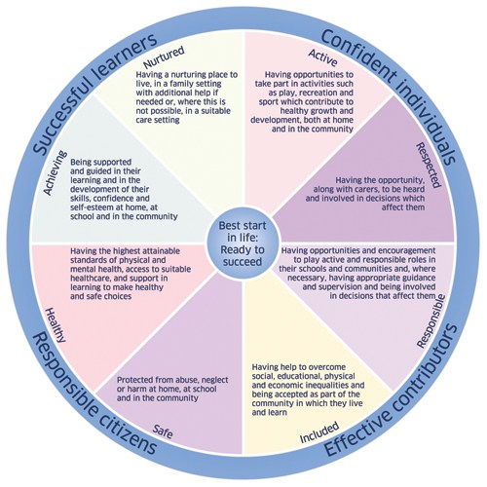
The acronym SHANARRI is formed from the eight indicators of wellbeing:
- Safe
- Healthy
- Achieving
- Nurtured
- Active
- Respected
- Responsible
- Included
All of these wellbeing indicators are necessary for a child or young person to reach their potential. They are used to record observations, events and concerns and as an aid to creating an individual plan for a child.

My World
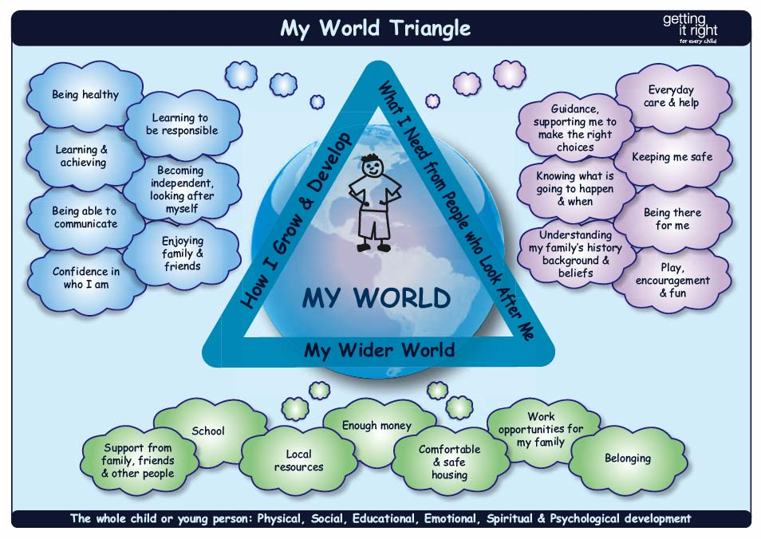
The My World triangle is a pictorial representation of an assessment tool used with individual children to determine which of their needs are being met, and where support is needed.

Appendix 2 – Health and wellbeing bundles

