

Currie Primary Nurture Policy
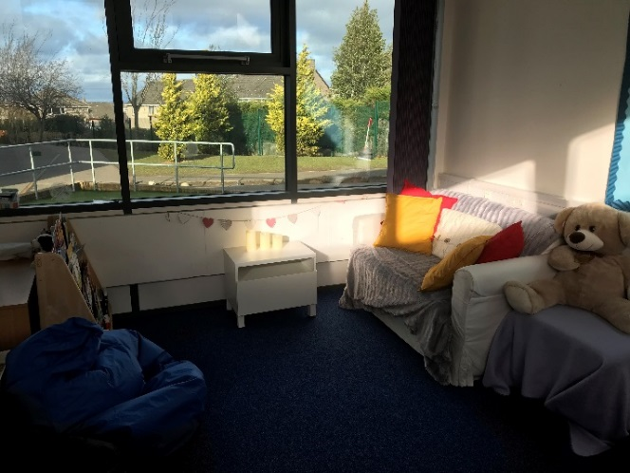

“To nurture, is to care and protect for something while it is growing”.

What is Nurture?

Nurture groups and nurturing approaches are increasingly being introduced across education settings in Scotland. Research demonstrates that nurture can have a very positive impact on the social and emotional well-being of children and can also help to raise attainment.

Getting it Right for Every Child

GIRFEC places children and young people’s wellbeing at the centre of all assessment and planning. It recognises that children and young people will have different experiences in their lives and have the right to expect appropriate support from adults to allow them to develop, grow and reach their full potential. Many of the key components of nurture can be found within the Nurturing approach, with a key focus being on well-being. It recognises that positive relationships are required to promote heathy social and emotional development and that these relationships should be reliable, consistent and predictable. The Nurturing approach has a key focus on the school environment and the balance between providing a warm, stable caring environment and promoting and celebrating attainment and achievement.

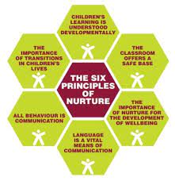
The Six Principles of Nurture
- Children's learning is understood developmentally.
- The classroom offers a safe base.
- Nurture is important for the development of self-esteem.
- Language is understood as a vital means of communication.
- All behaviour is communication.
- Transitions are significant in the lives of children.

Nurture at Currie Primary School
At the heart of Nurture at Currie Primary is a focus on well-being and relationships and a drive to support the growth and development of our children. In line with our school improvement plan. Our Nurturing approach seeks to support social and emotional well-being, promote positive behaviour and raise attainment.

Our Nurture Groups
Our Nurture Groups seek to offer a short term, focused intervention which helps to address some barriers that our pupils may have to their learning arising from social, emotional or behavioural challenges. Our team of highly trained and experienced staff run these groups in a supportive and inclusive manner, in line with the whole school Nurturing approach. We use many resources when working with groups but we have a special focus on using the Emotion Works programme. https://www.emotionworks.org.uk/



