

Currie Primary School

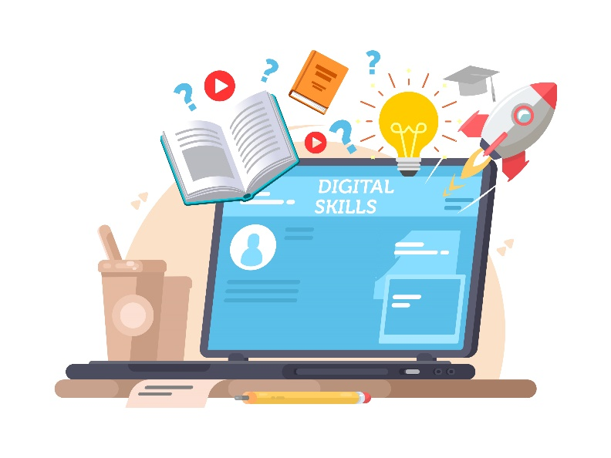

Digital Learning Policy

What is digital learning?
Digital learning is supported and enhanced by the use of digital technology. Digital learning prepares young people with the skills which can be utilised throughout life, learning and work, with focus on a range of technologies. Digital learning is used throughout all classrooms at Currie Primary equipping learners with transferrable skills which can be accessed through a variety of curricular areas.
What is digital literacy?
Being digitally literate means that learners can develop transferrable skills through the use of technology. They will be able to use their digital skills to support and develop their learning throughout the curriculum. Digital literacy is learning that can be encompassed throughout life, learning and working in a digital society.
Digital Learning Aims and Objectives at Currie Primary
Currie Primary understands that digital literacy is vital to the everchanging lives of learners and families. The Scottish Digital Participation Charter shares that the development of digital learning skills is vital to support citizens ‘do their jobs, live their lives and confidently use different digital services'. Their central aims are to:
- Develop the skills and confidence of educators in the appropriate and effective use of digital technology to support learning and teaching.
- Improve access to digital technology for all learners.
- Ensure that digital technology is a central consideration in all areas of curriculum and assessment deliver
Learning and Teaching
Digital technologies have become important additions to the classroom environment and are used by staff and pupils at Currie Primary in a variety of ways to enhance and enrich learner experiences.
Early Level (Nursery to P1)
Learners in the early levels of Currie Primary are likely to experience technology within a number of iPad related stations or areas centred on early literacy and numeracy skills. Learning is recorded by staff members with photographs and entries on Twitter and Learning Journals.
1st Level (P2 to P4)
In first level classes, shared iPads are used to support pupil’s learning with a range of approaches used from literacy and numeracy games to pupils recording their own learning journeys. Apps such have Teach My Monster to Read have become regular fixtures in P1 and P2 classes. Classes may record their skills and good practice through photographs, whilst transferrable skills such as scanning QR codes and early introductions to coding have been explored by some classes. Pupils in upper stages of first level utilise apps such as Book Creator and Keynote for collaborative tasks which can involve presenting information, completing research, or constructing audio/visual representations of their learning.
2nd Level (P5 to P7)
Like early and first level classes, P5 pupils benefit from the use of shared iPads within their classroom and through interactive whiteboard resources shared through the teaching staff’s Promethean boards and its related software. P6 and P7 utilise iPads in all areas of the curriculum on a 1:1 basis as part of Edinburgh City Council’s Empowered Learning programme. This saw 39,000 iPads issued to learners across City of Edinburgh Council schools. Further shared iPads will be deployed to learners from P1 to P5 as part of the Empowered Learning programme which seeks to develop the construction of digital literacy skills in all primary stages. See the Empowered Learning section for further details.
ASfL
Digital technology is used to support learners accessing ASfL with resources such as IDL Literacy used which benefits learners with dyslexia and literacy difficulties. Clicker is also utilised by several pupils in the school to support their writing and enhance their literacy skills. Seeing AI has also been used to provide an audio description of text resources. The launch of Empowered Learning in P6 and P7 has also benefited ASFL with pupils able to use the iPad’s accessibility features tailored to individual learners’ needs such as immersive reader, talk to text, magnified text and tinted backgrounds to support their learning. Pupils also utilise the camera function to have copies of board work beside them. Touch typing is also used within many classes to enhance children’s literacy skills.
iPad Use in Learning Contexts
Classes typically utilise some of the following apps which are approved by the City of Edinburgh Council’s self-service app centre:
- Microsoft Office including OneNote, OneDrive, Outlook, Teams, Numbers, PowerPoint, Whiteboard, and Word.
- Duolingo – Enhancing the use of digital skills in a modern language context.
- IDL Literacy - The IDL Literacy Intervention is a speaking-computer based multi-sensory system which supports learners with dyslexia and other learning difficulties to increase their reading and spelling ages.
- Bitsboard – Customisable spelling app.
- iMovie – Pupils have opportunities to bring filmmaking and video construction into their learning.
- Apple Classroom – Teachers have the opportunity to supervise learners’ iPad screens and direct them to useful apps and websites.
- Epic – A free e-library resource containing thousands of books for learners to access.
- Sumdog – Maths resource combining games and differentiated maths assessments.
- Accelerated Reader – Reading tool which assesses learner’s reading progress and allows them to log their personal reading records and take part in interactive literacy quizzes.
Empowered Learning
Empowered Learning was launched at Currie Primary in July 2022 and is being immersed in the P6 and P7 classes to enrich learning experiences and enhance digital literacy skills. The City of Edinburgh Council note: “These devices significantly enhance the learning experience through equity of access, encouraging innovation, evoking imagination, and nurturing a love of learning. The project will create a unique opportunity to unlock the potential of every learner across all schools and allow collaboration and innovation to flourish in our city.”
- Learners are regularly accessing resources, support materials and completing work through Microsoft OneNote with teachers able to electronically add specific feedback or voice notes through this.
- Learners develop their transferable digital literacy skills by using Microsoft Office Suite apps such as Word, PowerPoint and Excel.
- Learners and parents have a link to schoolwork at home through logging into pupil One Drives and through shareable Microsoft OneNote links.
- Learners utilise iPads for a variety of formative and summative assessment strategies implemented by teachers such as Padlets, Show Me Whiteboards, and QR surveys such as Plickers.
- Learners, parents and staff have signed a Responsible Usage Agreement to ensure iPads are used in a safe and appropriate manner linked with learning and teaching.
- A variety of resources and information packs regarding Empowered Learning can be accessed below
https://digitaleducationteam.com/empowered-learning/
Roles and Responsibilities
Members of the Currie Primary community take an active role in enhancing digital literacy within the school and developing the ICT skills of learners.
Teaching Staff
All teaching and support staff are given regular opportunities through CLPL to continually develop and enhance their digital knowledge and skills. This is done through whole school and additional optional external and internal training events, and through sharing good practice within our school and cluster. Teaching staff are responsible for planning opportunities for pupils to build on their digital literacy skills throughout a variety of contexts, exploring ICT approaches in relevant lessons.
Digital Learning Co-ordinator
The Digital Learning Co-ordinator takes a whole school responsibility over digital learning within Currie Primary School and is responsible for constructing a progressive whole school approach to the use of digital literacy within the school.
ICT Group
The Currie Primary staff working group focusses on the distribution of devices within Currie Primary and their subsequent management and organisation.
Pupil Digital Leaders – Currie Primary Tech Team
Pupils from every class from P4 to P7 gather at regular meetings to share their voice regarding Currie Primary’s digital technology. The group will focus on an ‘App of the Month’, provide technical support to fellow classmates (especially pupils in early level and first level), and promote events such as Safer Internet Day, celebrated in the school.
Digital Skills in Wider School Life
Celebrating Wider Achievement and Sharing Learning
Currie Primary shares the success of learners through use of individual class Twitter pages as well as a whole school Twitter page for general announcements. For individual class Twitters, followers must be approved by teachers and management to ensure content is secure. Parents and guardians can consent to whether their child appears on the school and class Twitter pages.
Currie Primary Website/School Twitter Page
Currie Primary share regular updates about events held within the school as well as photos and key dates on the school website which also has access to policies, important information for parents, and details about the school.
Homework
Digital literacy skills are encouraged at home with pupil homework shared on each class’s individual Microsoft Teams page.

