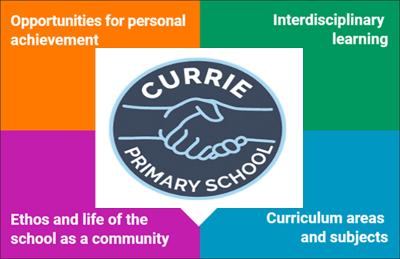
- Begin to develop P2 cooperative learning skills during outdoor learning:
- Staying on task
- Working/playing cooperatively in a group
- Encouraging others
- Being Responsible
- Active Listening
- The Sun and Moon.
- 6 weeks of Music Lessons with the YMI.

- Listening & Talking – Listen and respond respectfully, asking good questions. Burns poems recital.
- Phonics – Continue to decode and blend CVC/CVVC words. Introduce/consolidate consonant and vowel diagraphs.
- Reading – develop increased fluency and use expression appropriately. Develop thinking and comprehension skills.
- Writing – Continue to improve formation of letters. Apply common word and phonics knowledge. Focus on sentence structure, punctuation and adjectives. Poetry.
- Numeracy – Addition and subtraction, estimating and rounding.
- Maths – Data handling.
- PE – Ball skills and Scottish dance.
- HWB – Friends and friendship (RSHP – Relationships, Sexual Health and Parenthood)

- RME – Festivals and celebrations – Lunar New Year, Ramadan & Eid Al Fitr, Holi, Lent & Easter.
- The play pedagogy adopted in P2 allows us to be responsive to the children’s interest and cover all curricular areas.

- Assembly awards linked to the 4 capacities
- Sharing work with DHT/HT
- Celebrate wider achievements. We encourage you to share any achievements with us.

- SHANARRI – learning about SHANARRI
- Learning and applying our school values.
- Learning about children’s Rights and following
our Class Charter.
- P7 buddies.
- P7 paired reading buddies.
- Rights Respecting School, Eat Them to Defeat Them (school
lunches), Book Group and Eco class reps.
- Litter picking in the playground with our P7
buddies.
- Participate in the Scottish Assembly.

