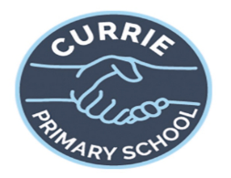

Numeracy and Maths:
This term we will be covering:
- - Money, Fractions, measure and revision and further
learning of add/subtract/multiply/divide and place value,
Literacy
This term in literacy the children will be working on:
- Reading - continuing to build comprehension skills.
- Spelling sounds – oy,ou/ow and silent/magic e.
- Grammar – use of adjectives and adverbs in our writing, alongside correct and interesting use of punctuation, sentence openers and connectives.
- Writing – up levelling pieces of writing, how to take notes, the features of an information leaflet and fact files.

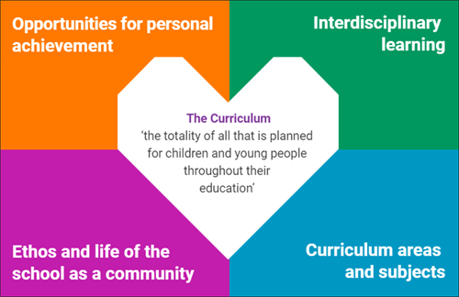

Rights Respecting School
- As part of a Rights Respecting School,
we will continue to use our class charter to ensure everyone’s rights are respected. This term we will also be taking part in Child Mental Health week (3rd February) and whole school activities.

Eco
- As part of being an Eco school we will be taking part in World Earth Hour on 21ST March.
- Air Pollution activities linked to The Air Pollution Programme.
- Assembly awards linked to the four capacities – Successful Learner, Confident Individual, Effective Contributor, Responsible Citizen.
- Table points, House points and weekly rewards.
- Sharing work and achievements with HT and DHT.
- Opportunity to be pupil of the week in Physical Education.
- Class Scots poem competition – the opportunity to learn and perform a Scots poem
- Circle Time – sharing achievements
Scotland: Each child will learn and perform a Scots poem. We will learn about Scots culture, language, cities and landmarks.
The Vikings: The IDL focus this term is The Vikings. The children will be researching all aspects of Viking life. In technologies they will be designing and making a number of Viking artefacts. In Expressive arts, the children will be learning some Viking themed songs, exploring different drama skills through role play and creating a variety of Viking themed artworks.
Health and wellbeing: This term we will be developing our growth mindset. Learning what it is, how it helps our attitude/approach to
learning, strategies we can use and building our
self-esteem and resilience.

V

