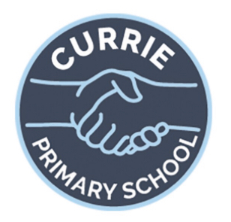
Primary 5, Term 3, 2025
- Measure – weight, volume
- Fractions
- Listening & Talking – Scots poem recitals
- Reading – group novels for most children
- New reading circle tasks
- Spelling – weekly spelling pattern
- Writing – poetry, biographies, personal account
- HWB – circle time, RSHP
- PE – with PE specialist Mr Donaldson
- Spanish – with Modern Languages specialist Mrs Ferguson
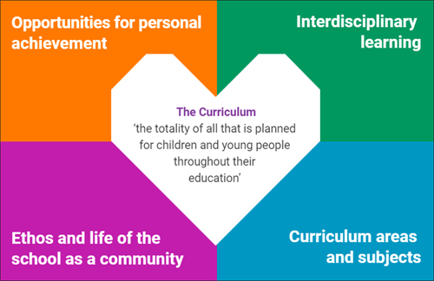
- Weekly assemblies
- Litter picking in the school grounds
- Individuals contributing to a range of school
council groups such as Eco, Digital, Fair Trade, Equalities, Pupil Council
- Weekly assembly awards linked to the 4 capacities
- Star of the week
- Sharing work with DHT/HT
- Positive notes home
- Weekend sharing at circle time
- Celebrating wider achievements
- Individuals participating in a range of school council groups
- Relationships, Sexual Health and Parenthood – following P5 official programme of work
- Art and Design (linked with enterprise, reading, writing, listening and talking)
- Textiles and design topic
- Ukulele
- Joy of Moving with Heart of Midlothian Football Club

