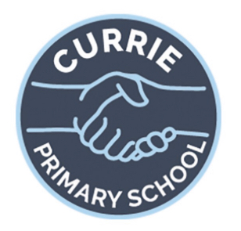
Primary 6, Term 3 2025
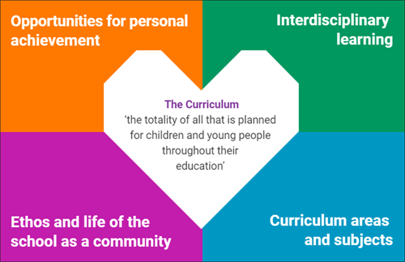
- Maths and Numeracy – Written methods for multiplication and division. Time – reading and telling time, converting between 12 and 24 hour time, reading timetables. Fractions, decimals and percentages. Patterns and relationships.
- Writing – instructions, character descriptions, recounts, imaginative writing.
- Reading – Novels – reading with fluency and expression using appropriate pace and tone. Skim a text to predict context. Identify purposes and main ideas in a text and pick out supporting details.
- Modern Languages- German with specialist
- PE- with PE specialist

- Team building activities
- Continue to celebrate festivals from different
faiths and religions
- Continue to embed our school values
- Buddying with P1
- Pupil council groups

- Assembly awards linked to the 4 capacities
- Table points and weekly reward
- Sharing work with DHT/HT
- Positive notes home linked to school values
- Weekend sharing on Monday
- Wider Achievements board and Shout Out board
- Weekly reflections
- Working towards Currie Outdoor Learning Award
- Technologies – further embedding the use of our 1:1 iPads across all curricular areas. Use of one note to support learning in class. Homework uploaded to teams each Friday.
- Expressive Arts – Scottish Opera ‘’The Tale o’ Tam’. Through resources provided by the Scottish Opera, children will be learning songs and dance movements for a performance on Wednesday 2nd April.
- RME – Focussing on places or worship, artefacts and celebrations for all world religions.
- RSHP – Emotional wellbeing and body image. Love and relationships.
Sex: How people have sex. How human life begins. Pregnancy and birth. Being a parent or carer. Menstruation.

