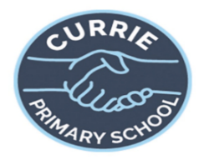
Primary 7 Term 3 2025
- Technologies – further embedding the use of our 1:1 iPads across all curricular areas. Continued focus on digital literacy skills through coding workshops and Safer Internet Day
- Decolonising the Curriculum: topic work
- Sustainable Development Goals-Ms McGovern
- My Diverse Scotland-block of live lessons
- Robert Burns poetry and ‘Burns Returns’ play
- Social Studies topic centred on features of democracy, elections, rights and responsibilities of citizens in Scotland
- Science topic- Solar System

- Embedding an ethos of SHANARRI across our
whole school.
- Focussing on our school values
- Embedding the language associated with
Rights, SHANARRI and Values.
- Embedding the Six Principles of Nurture and
The Currie Promise
- Providing a nurture space in the classroom
- Continuing to promote Fairtrade ethics throughout the curriculum
- Transition to secondary school through Cluster events
- Whole school charity events
- Developing the Young Workforce activities

- Maths/Numeracy – Fractions, Negative numbers, Patterns, Converting units of measure, Calculating Perimeter and Area
- Literacy – Reading – Voices in Park reading focus exploring characterisation, inference, prediction and point of view. Novels sent home for pupil homework. Developing Higher Order Thinking Skills with Blooms Taxonomy for Comprehension Writing – Imaginative: Point of View and Talk for Writing; Functional: non chronological report linked to Science; Personal Reflection about Camp Listening & Talking – Robert Burns poetry/Burns Returns play. Discussion, debate and P7 co-op skills embedded into lessons
- Continued spelling and grammar lessons
- Technologies – using OneNote to record learning and embedding use of digital literary skills with 1:1 iPads; presentations
- RSHP – Relationships Sexual Health and Parenting topic
- Health and Wellbeing – Risk factory visit
- Modern Languages – Mrs Ferguson
- PE – Mr Donaldson

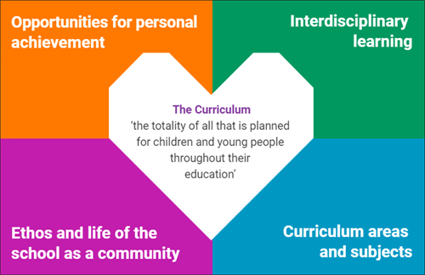
- Assembly awards linked to the 4 capacities
- Class/table points/House Points
- Star of the week Certificates linked to 4 capacities
- Sharing work with DHT/HT
- Positive notes home linked to school values
- Sharing classwork in PLPs
- Weekend sharing during Monday circle time/emotion check-ins
- Additional responsibility/leadership through monitoring
- Pupil leadership opportunities through different groups: Eco Council, IT Digital Council, Equalities Committee, Rights Respecting Schools, Reading Council, Fairtrade Committee, Eat Them to Defeat Them Pupil group
- House Captains
- Citizenship Award- personal challenge
- Specialist music instruction- Violin, Brass
- Representing the school at open days
- Transition Events and School Camp

